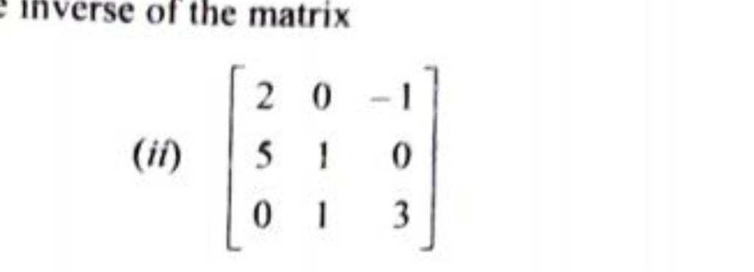
Find the determinant of the above matrix and write an algorithm for the same.

